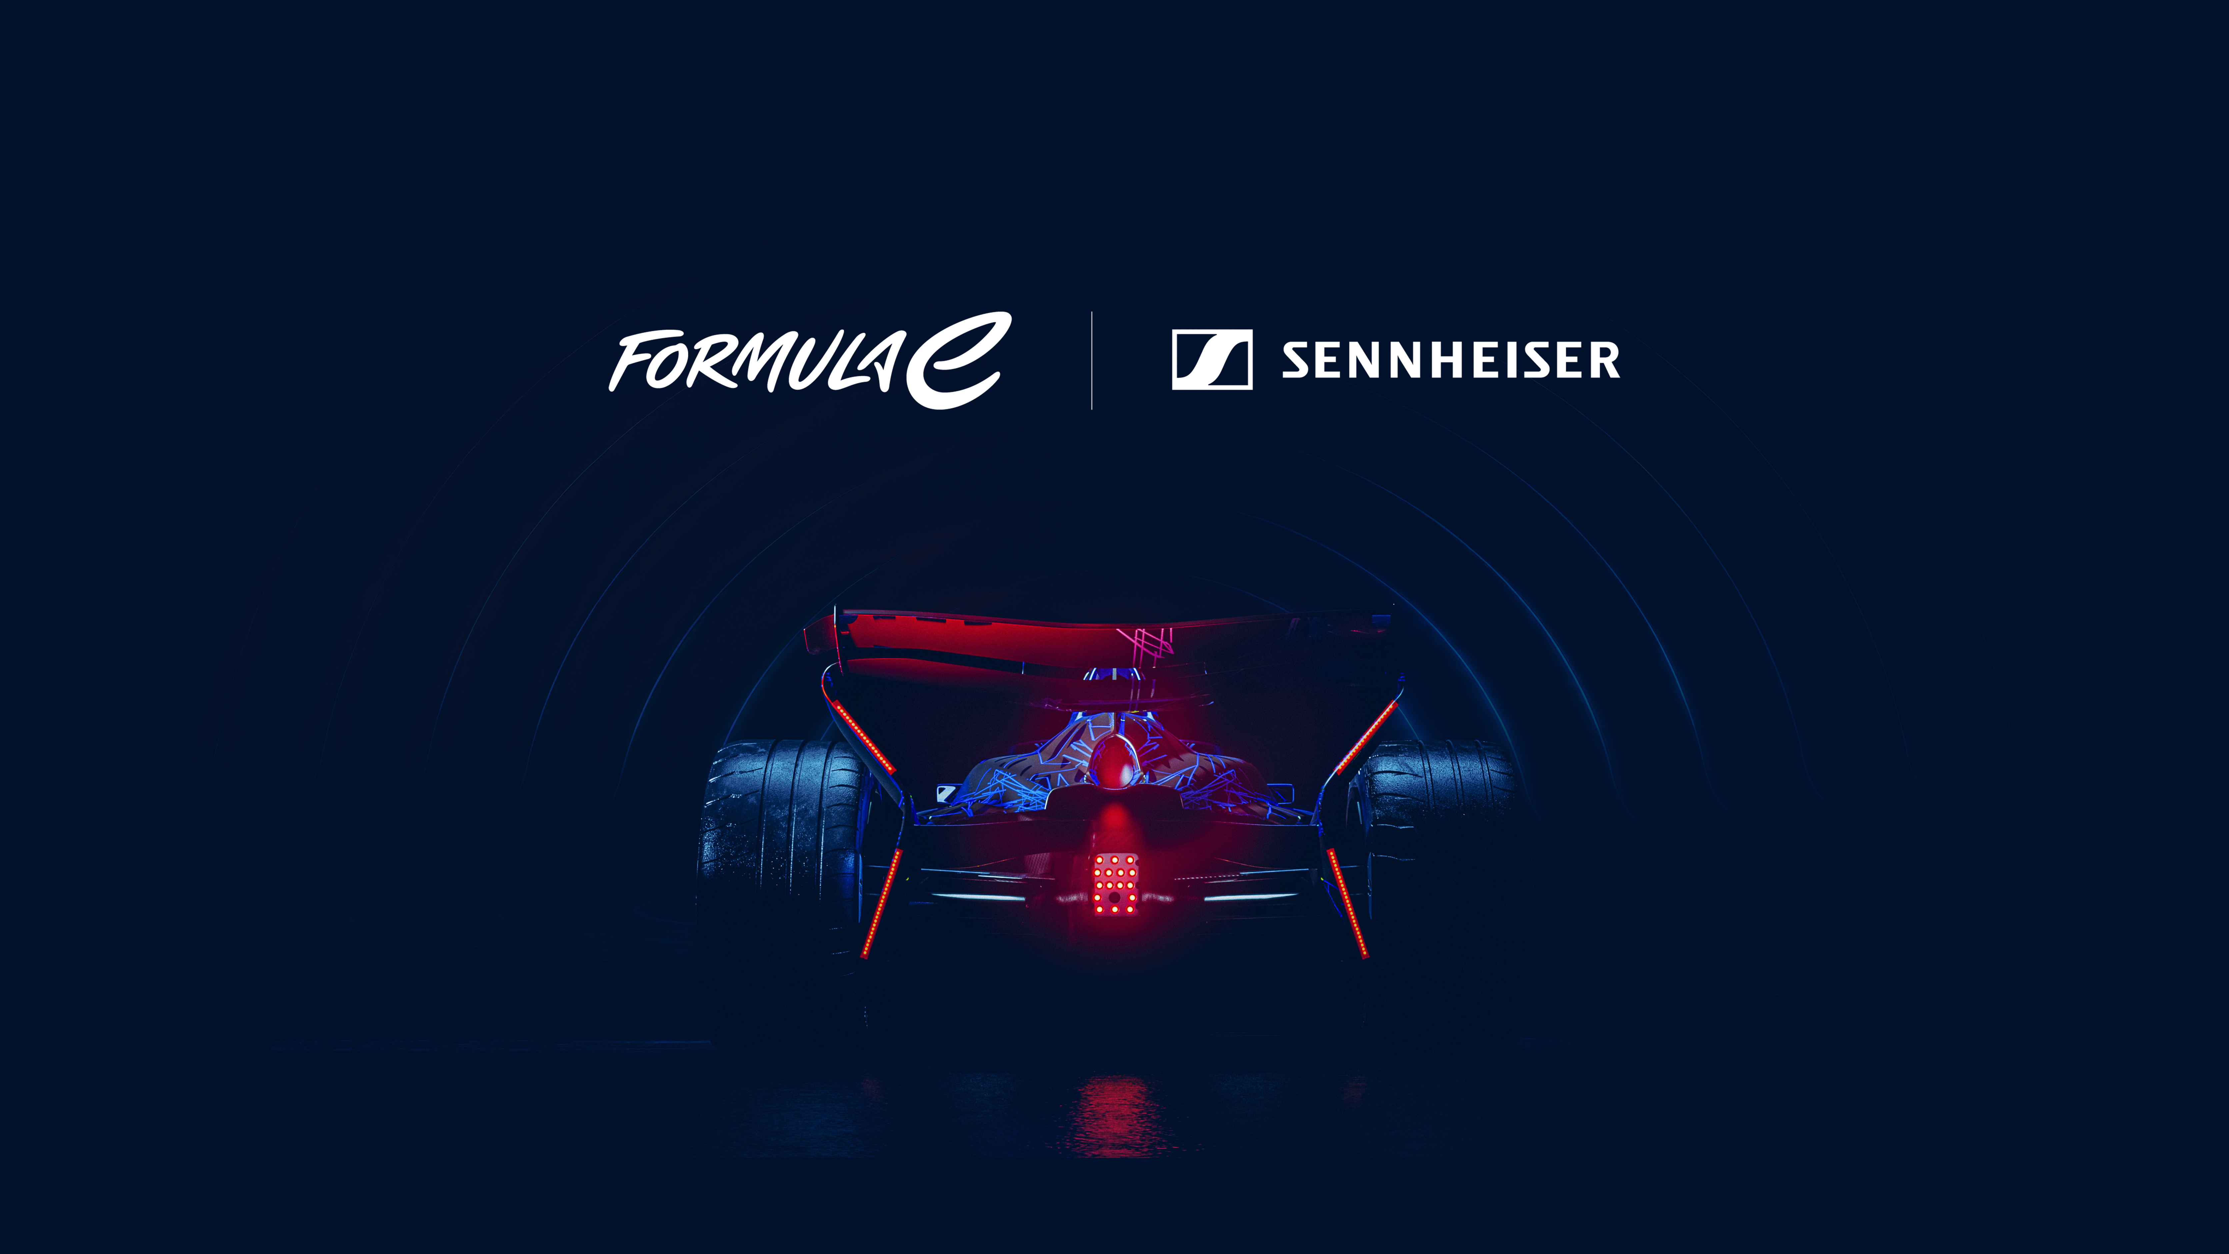

Sennheiser becomes Official Sound Provider of Formula E
Global audio specialist and Formula E join forces in a multi-year partnership to shape the future of immersive motorsport experiences

London, UK, 10 August 2026 – Formula E and Sennheiser have today announced a multi-year partnership under which Sennheiser, the world-renowned audio specialist, will become Formula E’s Official Sound Provider. The collaboration will see the ABB FIA Formula E World Championship integrate Sennheiser’s professional audio solutions and pioneering AMBEO immersive audio technology across the global series, creating new ways for fans to experience the excitement, energy and emotion of electric racing.

As the first all-electric FIA World Championship, Formula E continues to lead the way in sport-tech innovation. Through this partnership, Formula E and Sennheiser will explore how advanced audio capture and encoding workflows can create more immersive experiences for viewers watching on any device. By partnering with Sennheiser, the series aims to set a new global benchmark for live sports broadcasting and fan engagement, utilising Sennheiser’s expertise to capture the unique, high-performance soundscapes of the GEN3 Evo era and beyond.

“Innovation and technology are at the core of Formula E, and Sennheiser is the perfect partner to help us redefine the audio landscape of our championship,” says Dan Cherowbrier, CTO, Formula E. “Their professional audio technologies and workflows, particularly the AMBEO immersive ecosystem, provide a uniquely dynamic setting to explore the future of sound in racing. This collaboration is a vital proof point in how we connect real-world audio innovation with practical application, bringing fans closer to the action through natural, three-dimensional sound.”

“Formula E represents exactly the kind of environment where meaningful innovation happens,” says Andreas Sennheiser, CEO of the Sennheiser Group. “At Sennheiser, we are driven by the ambition to bring advanced audio technologies into real-world applications, and this collaboration gives us an exciting opportunity to rethink the role sound can play in electric racing. Great visuals deserve equally compelling sound, and we see real potential to define the sport’s unique acoustic character through dynamic in-car and trackside soundscapes. Ultimately, this partnership is about learning, exploring and helping to shape the future of how live sport is experienced.”

The technical partnership focuses on deep integration within Formula E’s broadcast and trackside operations. A key innovation driver for this collaboration is AMBEO, Sennheiser’s immersive audio technology and solutions ecosystem. “AMBEO enables the capture, processing and reproduction of natural, three-dimensional sound, supporting more immersive and emotionally engaging listening experiences,” concludes Kai Detlefsen, Manager, AMBEO at Sennheiser. “Within Formula E, AMBEO solutions will allow viewers at home to feel more closely connected to the dynamic racing environment and to their favourite teams.”

Beyond the broadcast, the partnership will also enhance Formula E’s onsite fan zones and VIP hospitality, ensuring that the Championship remains the most cutting-edge experience in sports entertainment.

The high-resolution images accompanying this media release can be downloaded here.

About the Sennheiser brand
We live and breathe audio. We are driven by the passion to create audio solutions that make a difference. Building the future of audio and bringing remarkable sound experiences to our customers – this is what the Sennheiser brand has represented for more than 80 years. While professional audio solutions such as microphones, meeting solutions, streaming technologies and monitoring systems are part of the business of Sennheiser electronic SE & Co. KG, the business with consumer devices such as headphones, soundbars and speech-enhanced hearables is operated by Sonova Holding AG under the license of Sennheiser.

www.sennheiser.com
www.sennheiser-hearing.com

About Formula E
The ABB FIA Formula E World Championship is known as the next evolution of motorsport. As the world’s first all-electric series, Formula E operates as a high-speed ‘living laboratory’ where innovation and adrenaline collide.

The championship has achieved the milestone of 150 races, and serves as a vital test bed for the world’s leading automotive manufacturers - including Porsche, Jaguar, Nissan, Stellantis, Mahindra and Lola Cars - to innovate and refine the electric vehicle (EV) technologies that will define future urban mobility.

Underpinning this performance is a profound commitment to impact. Formula E is a Certified B Corp - the world’s first and only sport to achieve this designation - reflecting its dedication to high standards of social and environmental transparency. It also recently became the first sport to achieve the BSI Net Zero Pathway certification, setting a new global benchmark for science-based climate action.

As a progressive challenger in the sports landscape, Formula E is defined by unpredictable, wheel-to-wheel competition. In 11 seasons, the series has crowned 10 different champions, proving it to be one of the most competitive and open titles in world championship-level sport. With a commitment to accessibility and a grid of world-class drivers and manufacturers, the series continues to rewrite the rules of elite sport, engaging a new generation who value purposeful ambition and fearless action.

www.FIAFormulaE.com

For Formula E media enquiries, please contact media@fiaformulae.com

About ABB
ABB is a global technology leader in electrification and automation, enabling a more sustainable and resource-efficient future. By connecting its engineering and digitalization expertise, ABB helps industries run at high performance, while becoming more efficient, productive and sustainable so they outperform. At ABB, we call this ‘Engineered to Outrun’. The company has over 140 years of history and more than 110,000 employees worldwide. ABB’s shares are listed on the SIX Swiss Exchange (ABBN) and Nasdaq Stockholm (ABB).

www.abb.com

Sennheiser Global Press Contact
Maik Robbe
maik.robbe@sennheiser.com
+49 (5130) 600 – 1028

